Bash Scripting Tutorial by Linuxconfig.org
This bash script tutorial assumes no previous knowledge of bash scripting.As you will soon discover in this quick comprehensive bash scripting guide, learning the bash shell scripting is a very easy task.
Lets begin this bash scripting tutorial with a simple "Hello World" script. Let's start with Learning the bash Shell: Linux/Unix Shell Programming
Note: the response to commands are shown in the boxes. In this example the host name is Linuxconfig.org, but wil be different in your case.

1.Hello World Bash Shell Script

First you need to find out where your bash interpreter is located. Enter the following into your command line:
which bash

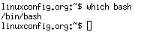

From the shell you can use the “nano” editor to edit files.
From the shell prompt in Linux create and edit a new text file called hello_world.sh
Use nano hello_world.sh
Using the nano editor – the mouse does not work in nano – you have to use the up/down and left/right arrow keys to move around the document. To save your work press the “Ctrl X” key combination, then hit the “y” key to save it and hit the Enter key.

NOTE:Every bash shell script in this tutorial starts with "#! /bin/bash" which is not read as a comment, but indicates where your shell interpreter is located.
Here is our first bash shell script example, so insert the following lines to the hello_world.sh file:

#!/bin/bash
# declare STRING variable
STRING="Hello World"
#print variable on a screen
echo $STRING

Make sure you are in the directory where your hello_world.sh is located then run ls –l to see if it is there, then make the file executable with: (note you will need to chmod +x all of your scripts!)
chmod +x hello_world.sh

Now you are ready to execute your first bash script: (note: you will need to run all of your scripts this way)
./hello_world.sh

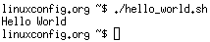

2.Simple Backup bash shell script
Now create a new file called backup.sh and add this script:
#!/bin/bash
tar -czf myhome_directory.tar.gz /home
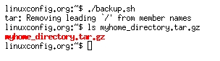

Don’t forget to chmod +x it and then run it as you did hello_world.sh

3.Variables
In Hello World we used variables by declaring a simple bash variable and printing it on the screen ( stdout ) with the echo command.
In our backup script we may want to identify our backup file by date.
Now modify backup.sh as follows and run it as before:
#!/bin/bash
OF=myhome_directory_$(date +%Y%m%d).tar.gz
tar -czf $OF /home

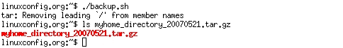

3.1.Global vs. Local variables
Now create a new script called variable.sh and execute it to test global and local variables:

#!/bin/bash
#Define bash global variable
#This variable is global and can be used anywhere in this bash script
VAR="global variable"
function demo {
#Define bash local variable
#This variable is local to bash function only
local VAR="local variable"
echo $VAR
}
echo $VAR
demo
# Note the bash global variable did not change
# "local" is bash reserved word
echo $VAR

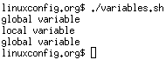

4.Passing arguments to the bash script

You may want the users of your script to be able to pass arguments from the shell prompt into the script. Create a script called arguments.sh as follows and execute it:

#!/bin/bash
# use predefined variables to access passed arguments
#echo arguments to the shell
echo $1 $2 $3 ' -> echo $1 $2 $3'
# We can also store arguments from bash command line in special array
args=("$@")
#echo arguments to the shell
echo ${args[0]} ${args[1]} ${args[2]} ' -> args=("$@"); echo ${args[0]} ${args[1]} ${args[2]}'
#use $@ to print out all arguments at once
echo $@ ' -> echo $@'
# use $# variable to print out
# number of arguments passed to the bash script
echo Number of arguments passed: $# ' -> echo Number of arguments passed: $#'

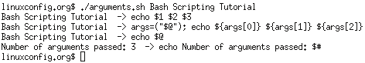

5.Reading User Input
You can also read text from the shell into a shell script. Create and run a script called read.sh:

#!/bin/bash
echo -e "Hi, please type the word: \c "
read word
echo "The word you entered is: $word"
echo -e "Can you please enter two words? "
read word1 word2
echo "Here is your input: \"$word1\" \"$word2\""
echo -e "How do you feel about bash scripting? "
# read command now stores a reply into the default build-in variable $REPLY
read
echo "You said $REPLY, I'm glad to hear that! "
echo -e "What are your favorite colours ? "
# -a makes read command to read into an array
read -a colours
echo "My favorite colours are also ${colours[0]}, ${colours[1]} and ${colours[2]}:-)"

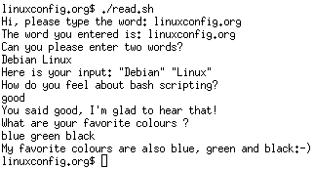

6.Bash if / else / fi statements

6.1.Simple Bash if/else statement
You can use if then else statements in a script. Create the follwing script and save it as bash_if_else.sh then execute it:
Please note the spacing inside the [ and ] brackets! Without the spaces, it won't work!

#!/bin/bash
directory="./BashScripting"
# bash check if directory exists
if [ -d $directory ]; then
echo "Directory exists"
else
echo "Directory does not exists"
fi

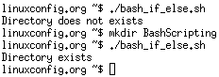

7.Bash Comparisons

You may need to do some comparison of numbers or strings in order to make decisions.

7.1.Arithmetic Comparisons

-lt | <
-gt | >
-le | <=
-ge | >=
-eq | ==
-ne | !=

Create the following script and save it as statement.sh.

#!/bin/bash
# declare integers
NUM1=2
NUM2=2
if [ $NUM1 -eq $NUM2 ]; then
echo "Both Values are equal"
else
echo "Values are NOT equal"
fi

Try different numbers for NUM1 and 2.

Then modify your script as follows:

#!/bin/bash
# declare integers
NUM1=2
NUM2=1
if [ $NUM1 -eq $NUM2 ]; then
echo "Both Values are equal"
elif [ $NUM1 -gt $NUM2 ]; then
echo "NUM1 is greater then NUM2"
else
echo "NUM2 is greater then NUM1"
fi

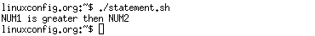

7.2.String Comparisons
= | equal
!= | not equal
< | less then
> | greater then
-n s1 | string s1 is not empty
-z s1 | string s1 is empty

Create the following script to compare strings:

#!/bin/bash
#Declare string S1
S1="Bash"
#Declare string S2
S2="Scripting"
if [ $S1 = $S2 ]; then
echo "Both Strings are equal"
else
echo "Strings are NOT equal"
fi

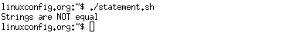

How could you modify your script to take two strings from the shell prompt?

8.Bash File Testing

You may want to test if a file exists with -e filename
Create this script, save it as filetesting.sh and execute it:
#!/bin/bash
file="./file"
if [ -e $file ]; then
echo "File exists"
else
echo "File does not exists"
fi


The file doesn't exist so enter the following to create it and then run the shell script again:
touch file


9.Loops

9.1.Bash for loop

#!/bin/bash
# bash for loop
for f in $( ls /var/ ); do
echo $f
done

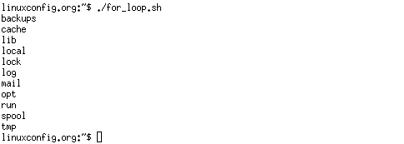

9.2.Bash while loop
#!/bin/bash
COUNT=6
# bash while loop
while [ $COUNT -gt 0 ]; do
echo Value of count is: $COUNT
let COUNT=COUNT-1
done

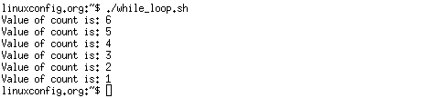

9.3.Bash until loop
#!/bin/bash
COUNT=0
# bash until loop
until [ $COUNT -gt 5 ]; do
echo Value of count is: $COUNT
let COUNT=COUNT+1
done

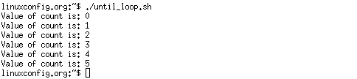

10.Bash Functions

#!/bin/bash
# BASH FUNCTIONS CAN BE DECLARED IN ANY ORDER
function function_B {
echo Function B.
}
function function_A {
echo $1
}
function function_D {
echo Function D.
}
function function_C {
echo $1
}
# FUNCTION CALLS
# Pass parameter to function A
function_A "Function A."
function_B
# Pass parameter to function C
function_C "Function C."
function_D

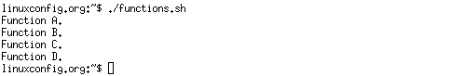

11.Bash Select

#!/bin/bash
PS3='Choose one word: '
# bash select
select word in "linux" "bash" "scripting" "tutorial"
do
echo "The word you have selected is: $word"
# Break, otherwise endless loop
break
done
exit 0

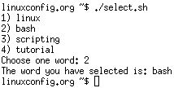

12.Case statement conditional

#!/bin/bash
echo "What is your preferred programming / scripting language"
echo "1) bash"
echo "2) perl"
echo "3) phyton"
echo "4) c++"
echo "5) I do not know !"
read case;
#simple case bash structure
# note in this case $case is variable and does not have to
# be named case this is just an example
case $case in
1) echo "You selected bash";;
2) echo "You selected perl";;
3) echo "You selected phyton";;
4) echo "You selected c++";;
5) exit
esac

